Centre for Sustainable Development Goals
National Cadet Corps (NCC)
Karpagam Academy of Higher Education (KAHE)
&
Karupa Institute of Development Initiatives (KIDI)

Jointly organized
The Webinar on “Poverty Eradication” International Human Solidarity Day (20-12-2020)

List of Activities
- Welcome Address
- Awareness lecture
- Discussion Session
- Feedback about the webinar
- Vote of Thanks
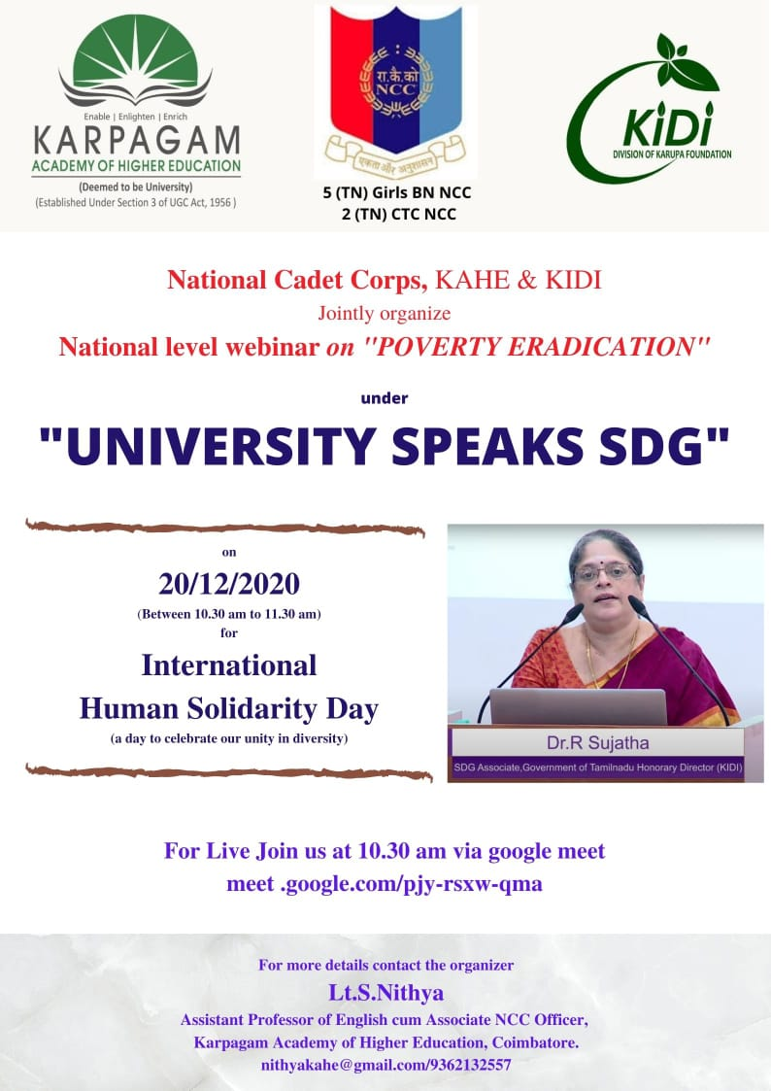
The National Webinar on “Poverty Eradication under University Speaks SDG” has been organized by the Centre for SDG, National Cadet corps- Karpagam Academy of Higher Education (KAHE) and Karupa Institute of Development Initiatives (KIDI) on 20-12-2020 at 10.30.a.m. On behalf of the organizing team Lt.S.Nithya presented a welcome address and introduced the speaker.
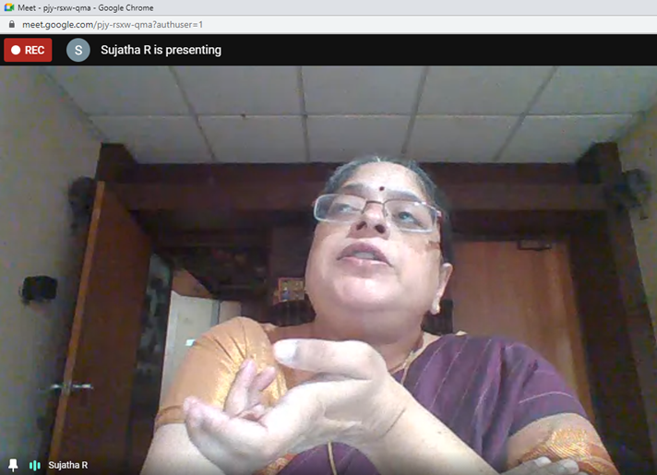
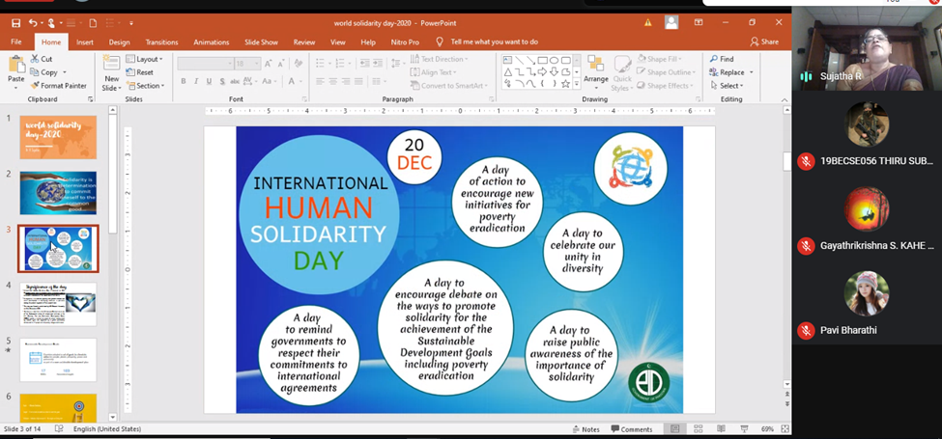
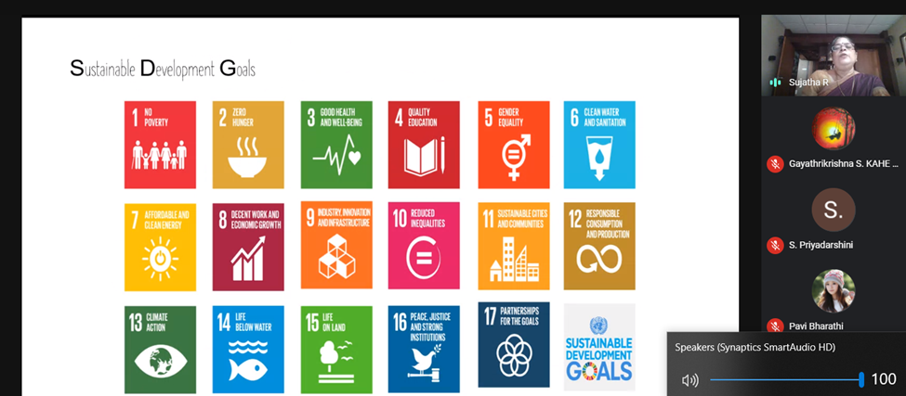
Our chief guest Dr R.Sujatha, Consultant with the state planning commission, Government of Tamil Nadu for the preparation of the Twelfth five-year plan. Around 100 participants were gathered to work together in fighting against poverty, hunger and disease on the Internal Human Solidarity Day.
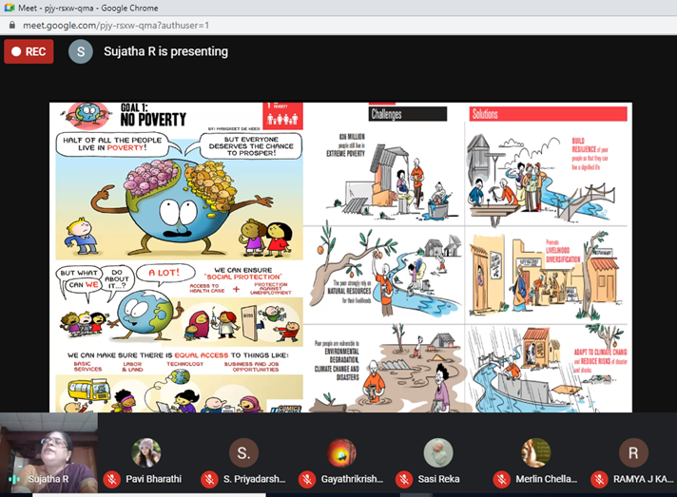
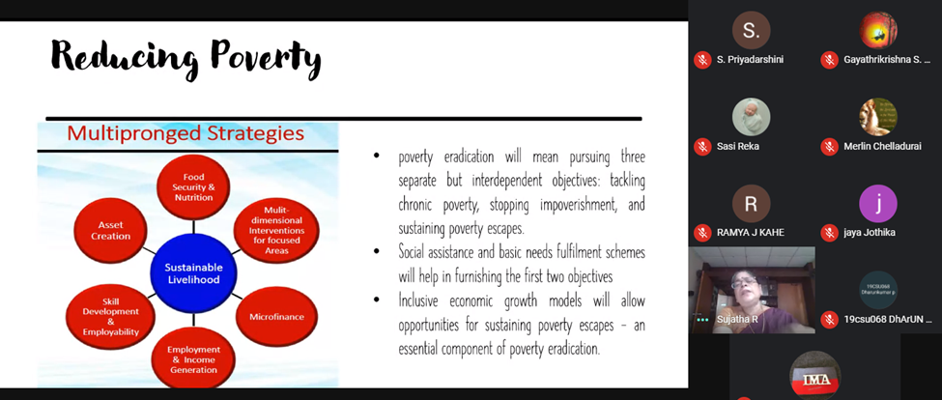
Our speaker explained that Poverty is more than just the lack of income or access to resources – it manifests itself in diminished opportunities for education, social discrimination and the inability to participate in decision-making processes. Under SDG, Poverty Eradication is one of the issues which has highly focused on.
Students have discussed with our chief guest and the feedback was provided followed by felicitation was done by Lt. Dr K.P.Sridhar, Convenor of the programme, At the end of the session, a Vote of thanks was delivered by Lt.S.Nithya, Programme Organizer.
The below mentioned drive link of the recorded webinar was published to other cadets through social media for awareness.
https://drive.google.com/file/d/1qjdklimENigwb48JSDB4PW4cpijBKSaT/view?usp=sharing

